**Candidate Variable Building Notes**

**Submission Summary**

Total Number of Candidate Variables: 3132

Total Attributes: 22

**Notes for Added Candidate Variables**

* Created new fields as requested:
  + namedob : firstname_lastname_dob
  + fulladdress : address_zip
* Linking Entities/Attributes:
  + 'ssn','address', 'dob', 'homephone', 'name', 'fulladdress', 'name_dob', 'name_fulladdress', 'name_homephone', 'fulladdress_dob', 'fulladdress_homephone', 'dob_homephone', 'homephone_name_dob', 'ssn_firstname', 'ssn_lastname', 'ssn_address', 'ssn_zip5', 'ssn_dob', 'ssn_homephone', 'ssn_name', 'ssn_fulladdress', 'ssn_name_dob'
* Day Since based on Attributes lists:
  + number of days since I last saw each attributes field
* Velocity:
  + number of records with the same [attribute] over the last [0, 1, 3, 7, 14, 30] days
* Relative Velocity:
  + number of applications with the particular [attribute] group seen in the past / the number of that same [attribute] group seen in the past [1, 3, 7, 14, 30] days
* Unique Counts:
  + number of unique [attribute] for that particular [attribute (other than the one before)] over the past [1, 3, 7, 14, 30, 60] days

**Additional Notes**

* 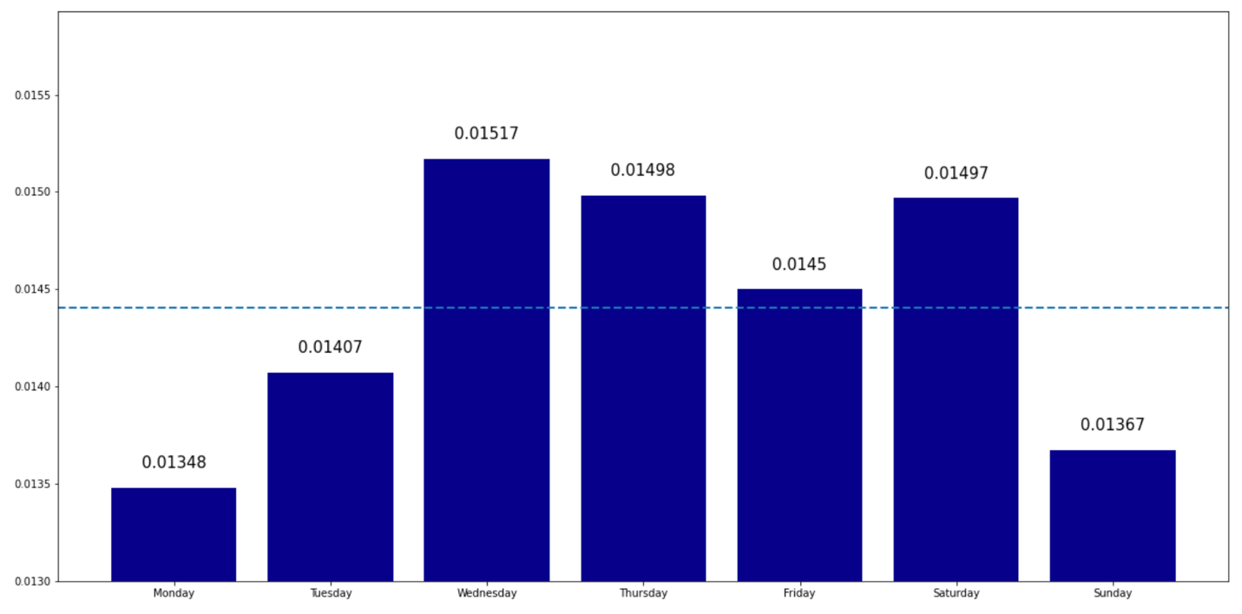Risk Table / Target Encoding graph for Fraud Proportion of each Week Day